* Configure access to your GitHub repo with SSH

windows

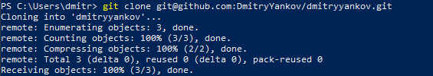

Ubuntu

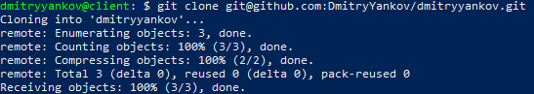

* Configure your user name and email for the repo (with git config command)

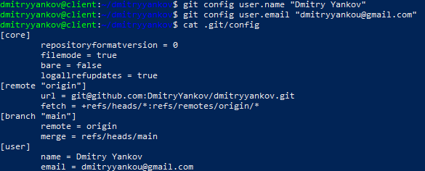

* Create branch from existing main

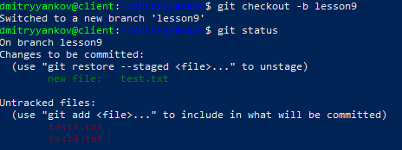

* Add few files, commit and push them to this branch

